**2nd Improvement proposed: Visual Problems in the application´s UI**

**The problem**

There are different types of visual problems across the Evergreen’s staff web user interface.

**What do I mean with “Visual problems”?**

Across the Evergreen’s staff web UI there are issues coming from different sources depleting the user experience. What these issues have in common is that they are all visual. I categorize them into three classes:

* Lack of visual consistency
* Confusing UI elements
* Readability reduction by bad color treatment

**Visual consistency**

Visual consistency refers to the consistent use of key visual design elements such as color, typography, UI elements as well as spatial layout.

A Consistent UI has many benefits:

* Makes UIs easier to use, because visitors don’t have to learn new tricks as they move around. In order words it reduces the slope of the UI learning curve.
* Provides reassurance for the users that they are still in the same place.
* Gives an overall impression of professionalism and reliability.
* When designing, removes the need to make the same decision time and again (will our field labels be left-aligned or right-aligned?), and it enables the use of templates and pre-defined snippets of code.

This concept is so important in design that great designers and organizations have taken it and converted it in a design principle:

* Don Norman’s design principles:
  + Taken from his book: *Preece, J., Rogers, Y., Sharp, H. (2002), Interaction Design: Beyond Human-Computer Interaction, New York: Wiley, p.21*
  + You can see the principles here: <http://www.csun.edu/science/courses/671/bibliography/preece.html>
* Apple OS X design principles:
  + The “Consistency” principle.
  + <https://developer.apple.com/library/mac/documentation/UserExperience/Conceptual/AppleHIGuidelines/HIPrinciples/HIPrinciples.html>

**Lack of visual consistency in Evergreen Staff UI**

The following sections are inconsistent with the rest of the UI:

* <https://webby.evergreencatalog.com/eg/staff/circ/patron/register>
* https://webby.evergreencatalog.com/eg/staff/circ/patron/1/edit
* <https://webby.evergreencatalog.com/eg/staff/circ/patron/1/edit_perms>
* <https://webby.evergreencatalog.com/eg/staff/circ/patron/1/triggered_events>
* <https://webby.evergreencatalog.com/eg/staff/cat/item/search>

The inconsistencies of the sections listed above are:

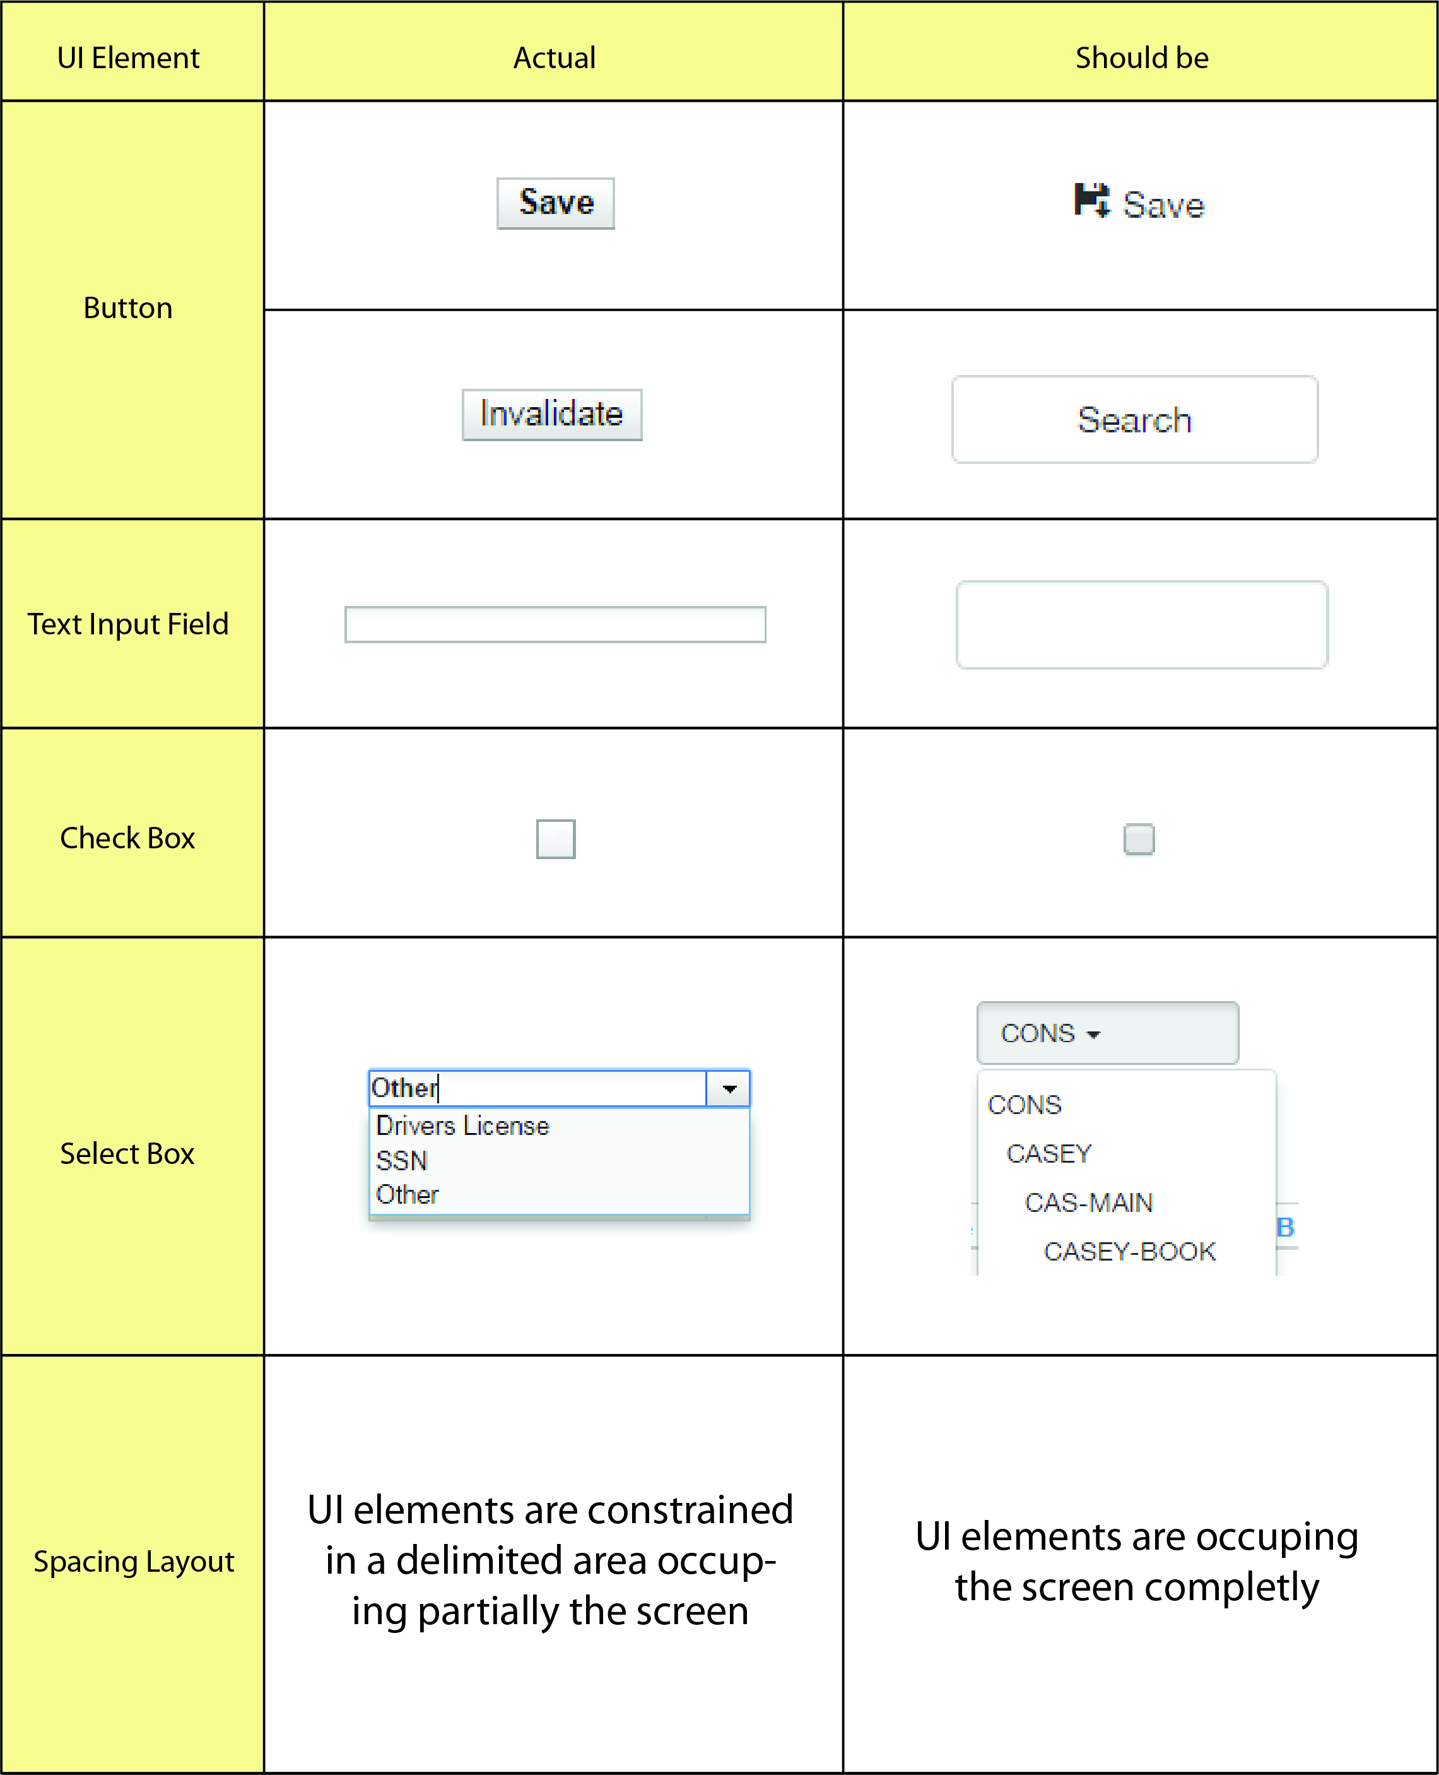

Another inconsistency can be found in the “circulation” subsections where the title of some subsection isn´t following a style guide, this means that we can find two different types of showing titles.

**Readability reduction by bad color treatment**

There are some text-background color combinations that the human eye find uncomfortable to read such as a text in red on a blue background or a text in any color on a colored-textured background, it always depends of how saturated each color is and the surface size. Therefore, knowing how to combine colors is essential for a UI in order to build a good user experience because it makes the texts easy to read.

The Evergreen´s staff web UI presents readability problems caused by bad color combination in the main menu when clicking a tab, and in the Patron Search UI’s submenu when selecting a tab containing patron data (like bills and the number of items checked out).

In the following graphic I summarize a proposal for solving this issue:

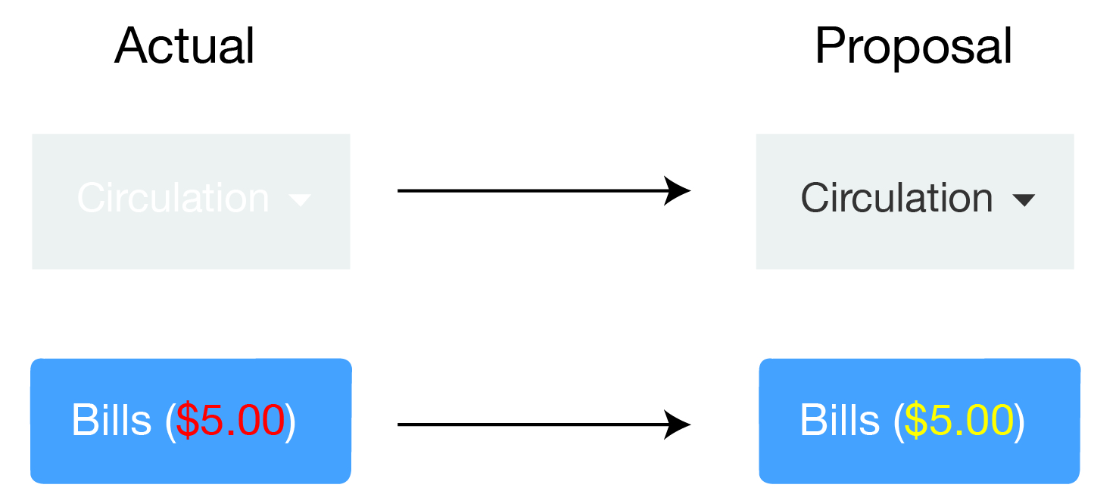

I focused on reducing color contrast between text and background in order to produce a comfortable perception and improve readability. Although this may be seen as a little improvement, this has a real positive effect on the user experience, because these readability issues are in critical places which are very used (they are both in menus) and contain important user data.

**Confusing UI elements**

There is a variety of UI elements that can look similar but serve different purposes for the user. As a rule, people don’t like to puzzle over how to do things. If people who build a UI don’t care enough to make things obvious it can erode confidence in the UI and its publishers. This is one of the rules that Steve Krug mentioned in his “Don´t make me think!” book. It is simple: people should not think when standing in front of a UI. Therefore, with a quick visual scan the user must be able to clearly identify the different UI elements and associate them to a specific functionality. This is why two different elements that look similar and provide different functions can confuse users and produce a poor user experience.

In the Evergreen´s staff web user interface this can be found in:

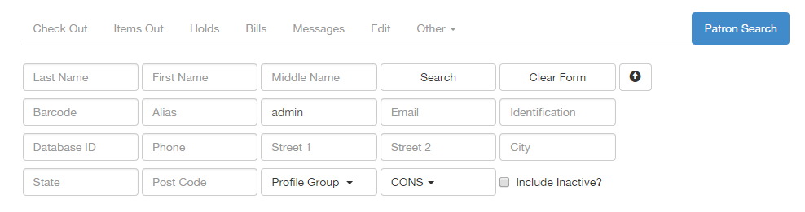

(<https://webby.evergreencatalog.com/eg/staff/circ/patron/search>)

Both the “search” and “clear form” buttons have an alignment and format very similar to the search’s field. In such way those buttons doesn’t stand out and can be confusing. Once you complete the form the user could feel invited to click the “Patron search” “button” in the right-top-corner, however, that’s not a button, it is just the title of the section where you are in. This is another confusion, it is look like a button but is not, is only part of the subsection menu. This happens because that specific section is separated from the rest in the submenu.

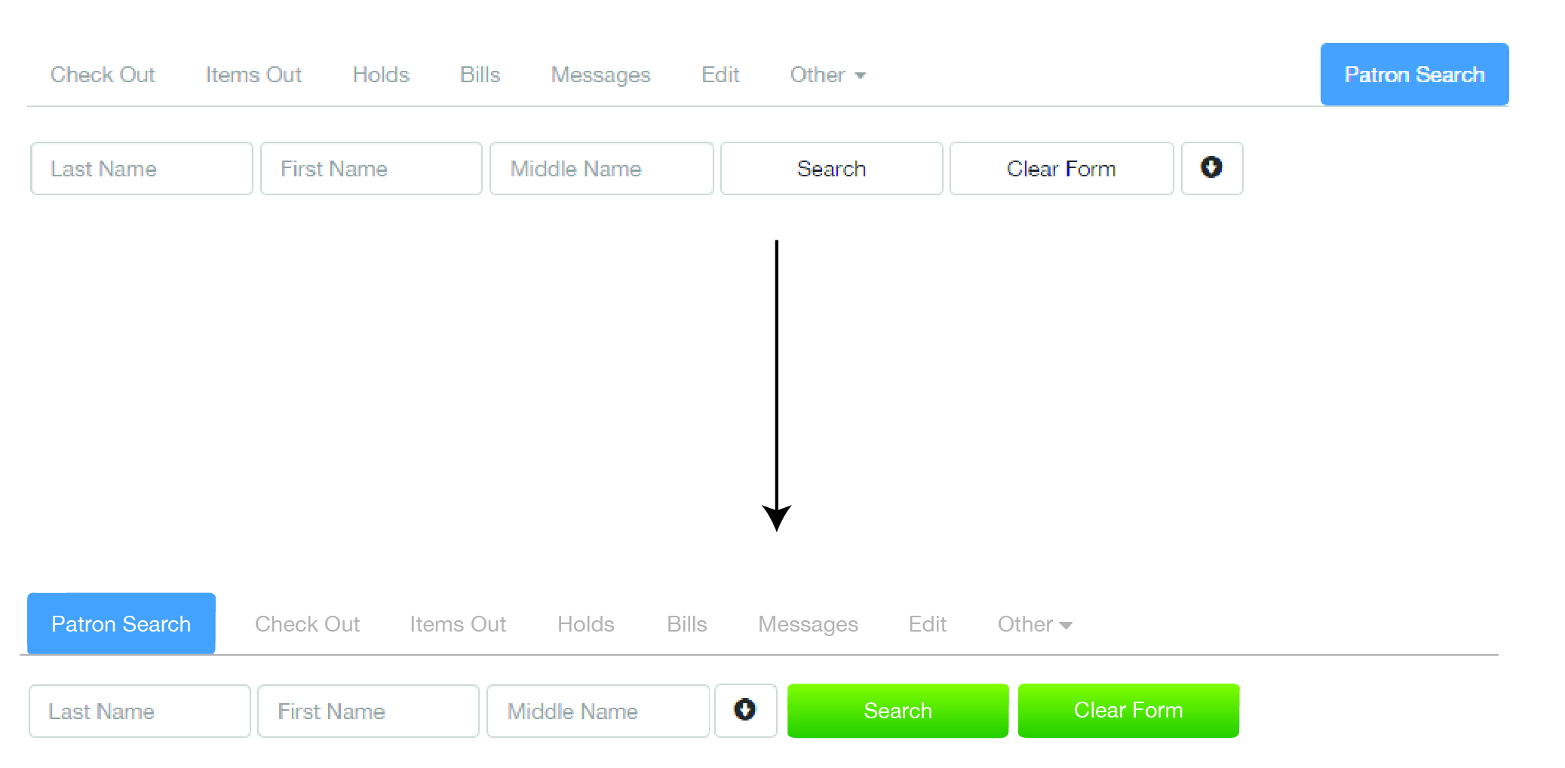

**Where those problems come from?**

We always need to have a guideline to follow. This should be one of the first steps in the conception of a project: define the aesthetic, the color, typography, language and investigate which are the patterns and common usage of UI elements. /*This is supposed to be designed by a professional who knows concepts of graphic and/or visual design. The designer should also consider the experience and culture of the intended users and be consistent with those expectations.*/

So, why “visual problems”? Visual treatment is frequently the area in which developers will have most freedom of movement. However, once you’ve chosen a visual language, it’s important that you stick to it. As the user moves through your site, the visual treatment provides reassurance that they are still in the same place, and gives an overall impression of professionalism and reliability.

Visual treatment applies not only to the obvious elements like logos and navigation, but also to content elements, fonts and backgrounds.

***References***

[***http://www.sitepoint.com/why-consistency-is-critical/***](http://www.sitepoint.com/why-consistency-is-critical/)

[***http://forumone.com/insights/design-principles-contrast/***](http://forumone.com/insights/design-principles-contrast/)

[***http://community.bestica.com/profiles/blogs/ease-of-learning-vs-ease-of-use-they-aren-t-the-same-thing***](http://community.bestica.com/profiles/blogs/ease-of-learning-vs-ease-of-use-they-aren-t-the-same-thing)

[***http://www.uxbooth.com/articles/10-usability-lessons-from-steve-krugs-dont-make-me-think/***](http://www.uxbooth.com/articles/10-usability-lessons-from-steve-krugs-dont-make-me-think/)